<https://git-scm.com/book/en/v2/>

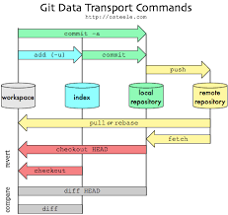

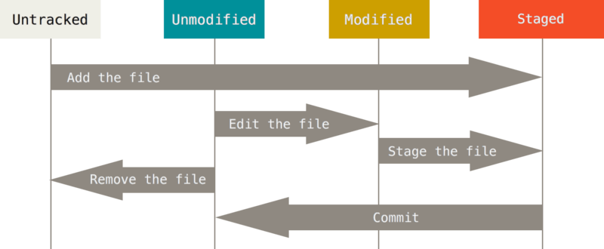

|  |  |
| --- | --- |
| **Command** | **Description** |
| cd *directory* | Go to directory |
| git init | Initialize directory as a git directory |
| git add *files* | Add files to be tracked or files that were edited to be staged |
| git status | Checks if any tracked file was modified & branch name |
| git clone *url* folder_name | Clone existing directory |
| git commit –m “*description*”  **git commit –a –m ‘*description*’ commits all tracked files that were modified | Push staged changes to local |
| git rm *file*  ** git rm --cached *file* | deletes file  ** Removes file from tracked files |
| git mv *file1* *file2* | Moves file1 to file2 (may be folder + new name) |
| git log | Displays changes made to repository |
| git reset HEAD *file* | Takes files off staging |
| git push | Pushes committed files to GitHub |
| git checkout *file*  git checkout *branch* | Undo all changes made to file  Switches to another branch |
| git pull | Changes local files to latest version (files change) |
| git fetch *remote-name* | Updates local repository to latest version (only version change, files remain same) |
| git branch *branchName*  ** -d tag to delete branch | Makes a new branch |
| git merge *branchName* | Merges branchName to current branch |

*Italicized_text* = replace text with appropriate value (ie. cd *directory* => cd C:\Program Files (x86))

Underlined_text = optional text, replace text with appropriate value or ignore tag   
(ie. git clone <https://github.com/libgit2/libgit2> or git clone [https://github.com/libgit2/libgit2 mylibgit2](https://github.com/libgit2/libgit2%20mylibgit2))

.gitignore file used to list ignored files in git status command (glob patterns, start wit / to avoid recursively, end with / for folders, # are comments)

git config –get remote.origin.url for GitHub url